**FDA Lab4**

**Q1.** Declare a data frame named as **Stu_Result** of 15 students with attributes Reg.No, Name, M1, M2, M3, M4 and M5.

1. Calculate the Average of Marks in another vector and append it to the **Stu_Result.**
2. Then append another column as Grade with respect tothe table given below. The resultant data frame name should be **Updated_Stu_Result**

|  |  |
| --- | --- |
| Average | Grade |
| >90 | S |
| 81-90 | A |
| 71-80 | B |
| 61-70 | C |
| 51-60 | P |
| <=50 | F |

1. Create another data frame named as **New_Stu_Result** with the attributes

Reg.No, Name, M1, M2, M3, M4, M5, Avarage, and Grade.

**Q2.** Create a data frame as given below

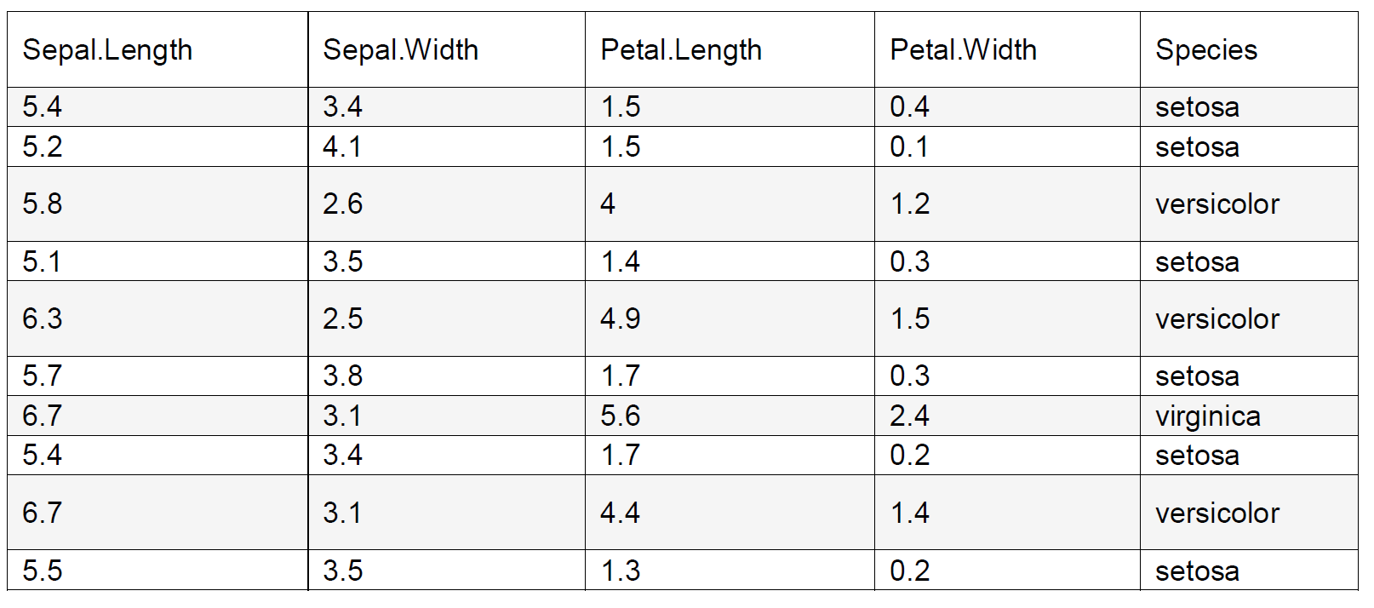

1. What are the mean and median of the column “Sepal.Length”?
2. What is the mode of the column “Species”?
3. What are standard deviation and variance of the column “Petal.Width”?
4. What is the normalized value of 2.5 in the column “Sepal.Width” using min-max normalization having new minimum value as 11 and new maximum value is 13.
5. What is the normalized value of 2.5 in the column “Petal.length” using z-score normalization?